

DEPARTMENT OF INFORMATION TECHNOLOGY
SCHOOL OF COMPUTING AND INFORMATICS

LOGBOOK: MOBILE APPLICATION DEVELOPMENT
UNIT CODE: BIT4107
NAME: YUSUF ANEMBA
REGNO: BIT/2020/90745
PROJECT NAME: SCHOOL MANAGEMENT APPLICATION

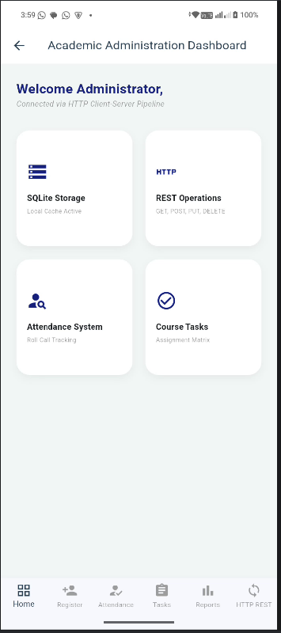
Figure 1.1 admin home screen
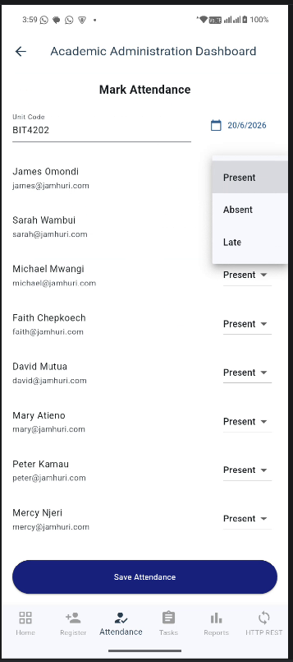
Figure 1.2 individual attendance report in SQLite with a relationship to the students
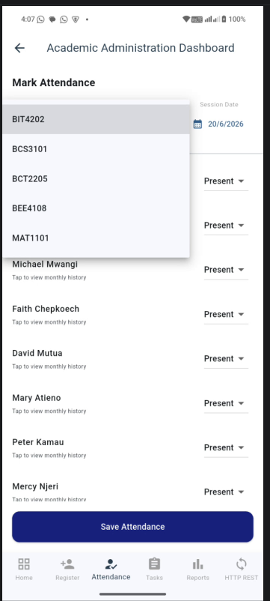
Figure 1.3 drop down option to toggle between different units.
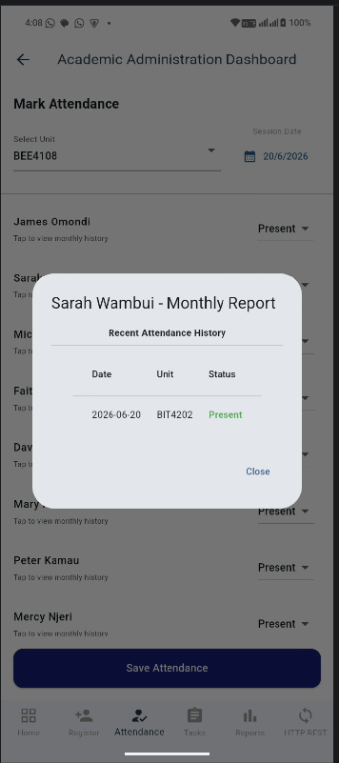
Figure 1.4 option to view a specific student record in the system
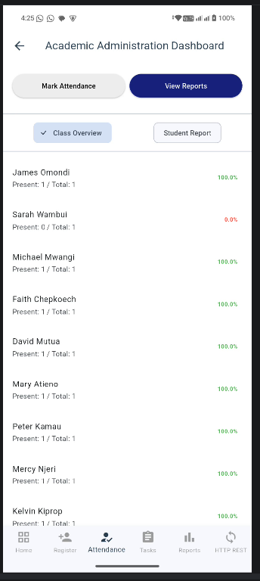
Figure 1.5 students report and a general class overview of the attendance of the students and the dates they were in class and those that they were not in class.

TOOLS AND TECHNOLOGIES USED
For the development of the JAMHURI STUDENT MANAGENT APP, I used the following tools,
- Flutter SDK
- Dart
- SQFlite. Local database to store students’ records.
- Android studio
- Android emulator/ my android phone

